Saraswati Vadnais

Writing Portfolio

This portfolio contains technical writing, instructional design, and UI writing samples. Most of my technical writing work was completed during my position as a technical writer at Visa, Inc. from 2022 to 2024. However, due to the confidential nature of this work, I am unable to include any of my writing for Visa in this portfolio. Instead, I am including an unpublished user guide for the Taiwan Railway E-Booking app, a Zoom user guide that I created for , and a presentation I created to train incoming math tutors.

as well as a proposed re-wording of the UI to improve clarity for a non-Taiwanese end user.

Contents and Notes:

1. **UI Documentation Sample – Taiwan Railway E-Booking App User Guide**

This is an unpublished user guide for purchasing train tickets on the Taiwan Railway E-Booking app. The app is primarily used by Taiwanese users in Mandarin Chinese; however, the English language version of the UI is a bit confusing to navigate for a first-time user and currently lacks official English documentation.

1. **Technical Writing Sample – Zoom Scheduling User Guide**
2. **Instructional Design Sample – Carleton College Quantitative Resource Center Tutor Training Program**
3. **UI Writing Sample – Taiwan Railway E-Booking App Redesign**

The UI of the Taiwan Railway E-Booking app currently has many typos, inconsistencies, and confusing buttons. I have edited the UI to make it easier to navigate for end-users.

January 2, 2025

Taiwan Railway E-Booking App

User Guide

Contents

Taiwan Railway E-Booking App Overview 2

Taiwan Railway E-Booking Home Screen 3

Book a Train Ticket on the Taiwan Railway E-Booking App 4

Pay For Tickets on the Taiwan Railway E-Booking App 6

Collect Paid Tickets on the Taiwan Railway E-Booking App 10

## Taiwan Railway E-Booking App Overview

The Taiwan Railway E-Booking app allows users to purchase electronic tickets for express trains in Taiwan. These trains require advance booking to guarantee a seat, and certain trains do not allow passengers to board without a reserved ticket. The trains available to book on the Taiwan Railway E-Booking app include:

* Tze-Chiang Limited Express (3000)
* Taroko Express
* Puyuma Express
* Taichung Limited Express
* Chu Kuang Express

Once purchased, riders can use a QR code, accessed through the Taiwan Railway E-Booking app, to board the train.

The Taiwan Railway E-Booking app cannot be used to purchase Taiwan High Speed Rail tickets or Taiwan local train tickets.

## Taiwan Railway E-Booking Home Screen

The Taiwan Railway E-Booking home screen allows users to view train information, purchase tickets, and view tickets they have booked.

Taiwan Railway E-Booking Home Screen and Navigation Pane

  
This is an overview of the features on the Taiwan Railway E-Booking home screen.

* **Tickets** – View train tickets that have been paid for and collected on the app.
  + Tap **Tickets** on the Taiwan Railway home screen to display a list of all your available train tickets.
  + Tap any ticket to display a QR code, which can be scanned at the train station gates.
* **Unpaid** – View and pay for train tickets that have not yet been paid for. If you have booked a ticket but have not yet paid, you must pay for the ticket by the end of the next day.
* **Uncollect** – View and collect (receive the QR code) for train tickets that have been paid for but have not yet been collected. Tickets can be collected up to 10 minutes before the train’s scheduled departure time.
* **Issue Ticket** – Transfer tickets that you purchased to other riders.
* **Booking Ticket** – Book a train ticket.
* **Timetable** – View scheduled arrival and departure times based on specified departure and arrival stations, and a time range.
* **Train Information** – View scheduled arrival and departure times based on a train number and departure time.
* **Live Train Info** – View the live arrival and departure times for all trains at a given station and on a specified date (up to two weeks in advance). Train delays, cancellations, and other changes in schedule will appear on this screen.

Tap the hamburger menu icon (three lines) to display a navigation pane with additional features such as settings, bicycle vacancies, and contact information. The **R** logo in the navigation pane can be tapped at any time to return to the home screen.

## Book a Train Ticket on the Taiwan Railway E-Booking App

To book train tickets on the Taiwan Railway E-Booking app:

1. Tap **Booking Ticket** on the Taiwan Railway home screen.

The Booking Ticket screen will appear.

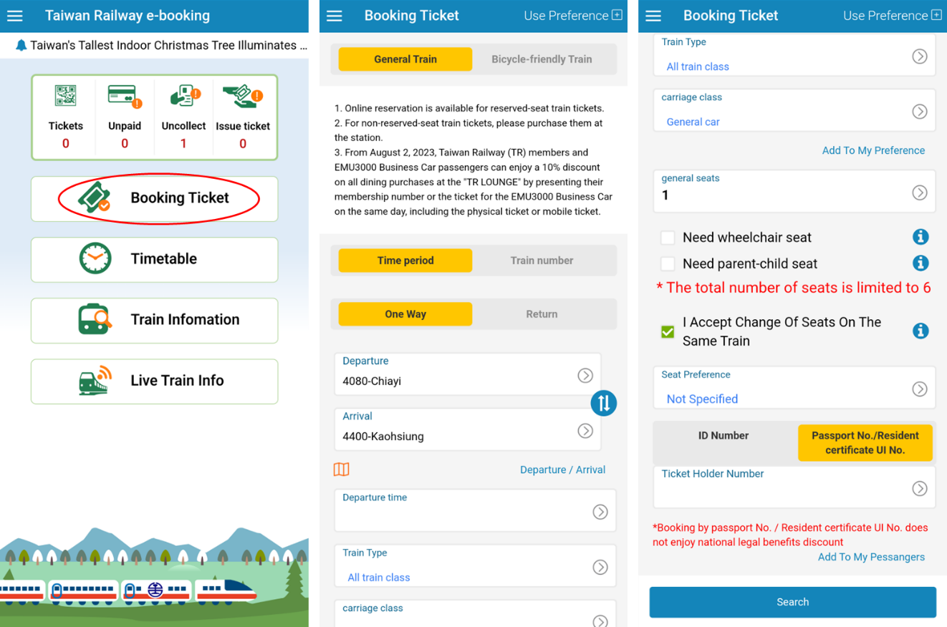

1. Set your **Departure** station and **Arrival** station.
2. Tap **Departure Time**. A pop-up calendar will appear. Select your departure date and tap **OK.**
3. A pop-up clock will appear. Select your departure time and tap **OK**.
4. Tap **Train Type**. A checklist of different express train types will appear. Trains primarily differ by speed and seating arrangement.
5. Check the box by the train you wish to take. If you do not prefer a certain train, check the **All** box. Tap **OK**.
6. Select your carriage class (general car or business car).
7. Indicate how many seats you need by tapping **General Seats** or **Business Seats** (depending on your chosen carriage class)and selecting a number between 0 and 6. You cannot purchase more than 6 tickets in a day.
8. If needed, indicate if you need a wheelchair seat and/or a parent-child seat by checking the relevant boxes.
9. **I Accept Change of Seats on The Same Train** is automatically checked. This means that you may have to change seats in the middle of your train trip if a single seat is not available for the entire trip duration. If you do not accept this, uncheck the box.
10. Indicate if you have any seat preferences by tapping **Seat Preference**. Preferences for window seats, aisle seats, or table seats will be considered when the system assigns you a seat. If you have no preferences, select **Not Specified.**
11. Input your ID number in the **Ticket Holder Number** field.
    1. If you are a Taiwanese citizen, select **ID Number** and input your Taiwanese ID number.
    2. If you are a foreign citizen, select **Passport No./Resident certificate UI No.** and input your chosen document ID (passport or resident card number).
12. Tap **Search.**

A list of all available trains will appear.

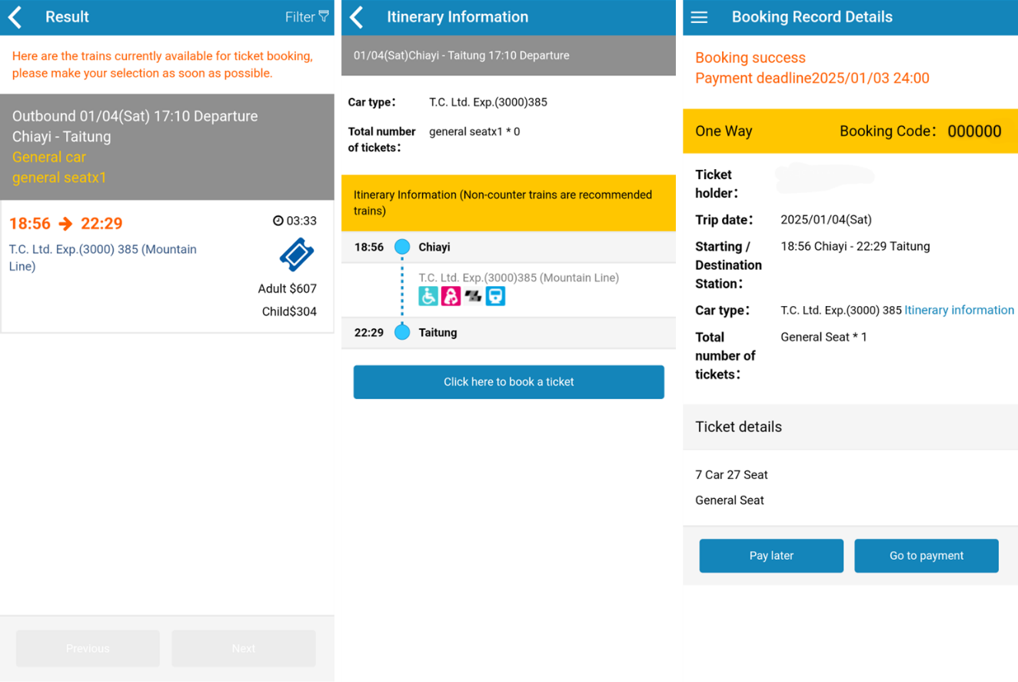

1. Select the train you prefer.
2. A screen with itinerary information will appear. Tap **Click here to book a ticket**.
3. The **Booking Record Details** screen will appear. This screen displays the payment deadline, ticket details, and booking code.
4. Tap **Pay later** to complete the payment later (must be before the payment deadline) or tap **Go to payment** to proceed with the payment.

You have now reserved a seat. However, you must pay for the booking by the end of the next day to be issued a ticket.

## Pay For Tickets on the Taiwan Railway E-Booking App

Follow this procedure to pay for any tickets that you have booked and obtain the QR code for use in the train station.

If you select **Go to payment** after booking a ticket, continue to **Step 2**.

1. If you select **Pay later** after booking a ticket, tap **Unpaid** on the Taiwan Railway E-Bookinghome screen to access your unpaid tickets. You can also access your unpaid tickets by opening the navigation pane, going to the **Tickets Service** dropdown and tapping **Pending Bookings**.

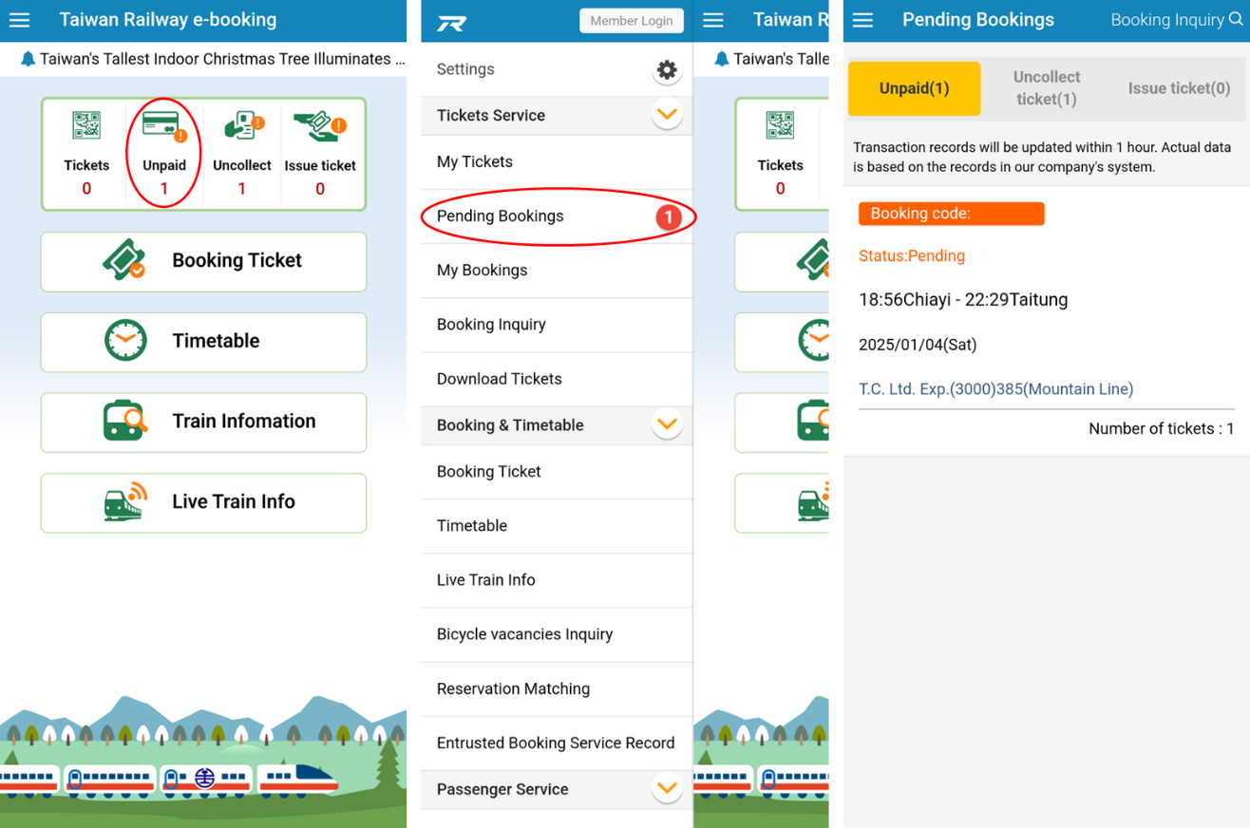

* 1. Tap the booking you would like to pay for.
  2. On the **Booking Record Details** screen, tap **Go to payment**.

1. The **Ticket Type Setting** **and Purchase Lunch** screen will appear.

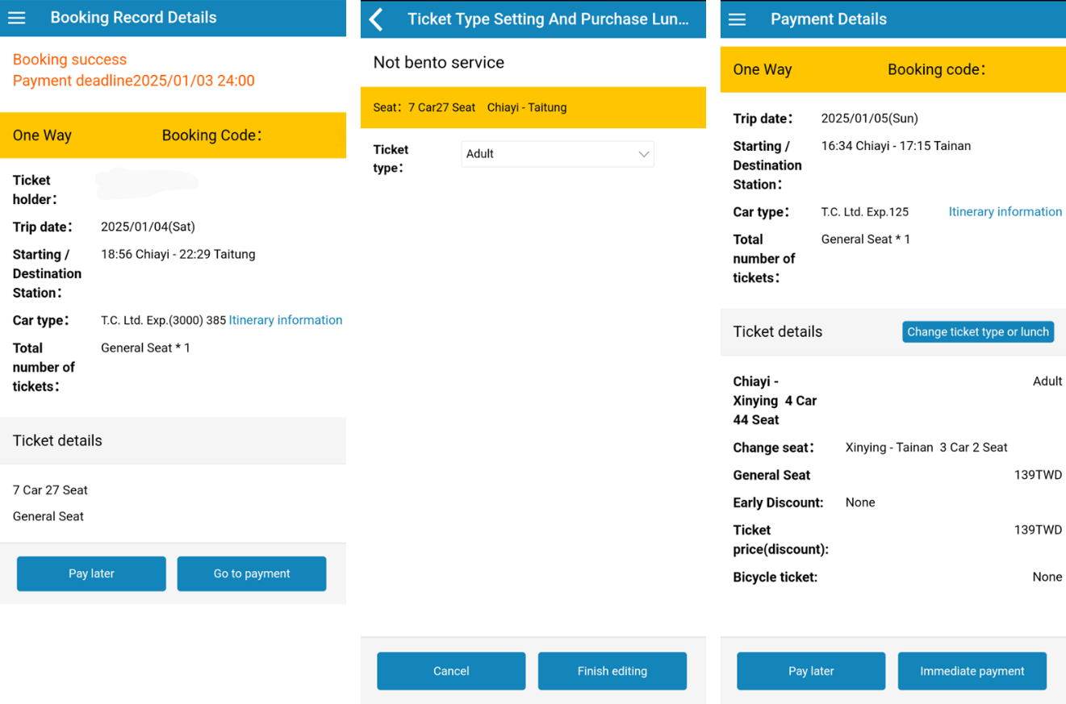

1. In the **Ticket type** dropdown, indicate if this is an adult ticket or a child ticket.

Depending on your train type, there may be an option to purchase a bento lunch box.

1. Tap **Finish Editing**. The **Payment Details** screen will appear.
2. Check the details of your ticket. If you need to make any changes, tap **Change ticket type or lunch**. Tap **Immediate payment**.

The **Payment Only Part of the Ticket** screen will appear.

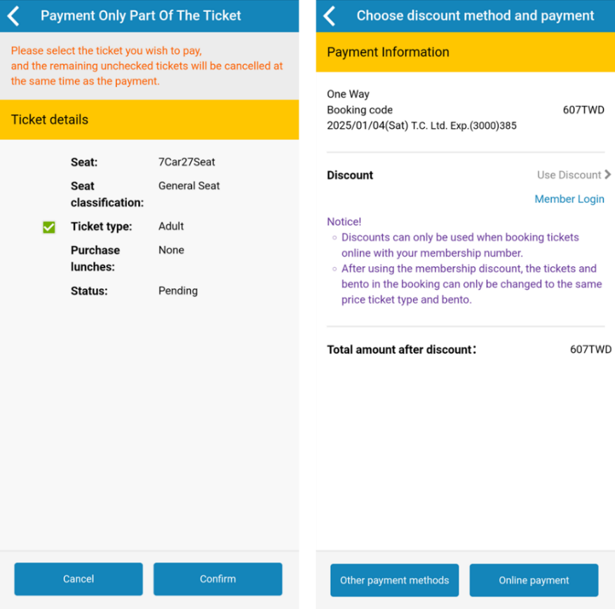

1. Check the box next to the tickets you wish to pay for. All other unchecked tickets will be cancelled.
2. Tap **Confirm**.

The **Choose discount method and payment** screen will appear.

1. If you are a member, you may log in using the **Member Login** button and apply any discounts here.
2. Pay for your ticket. There are two options for payment: in-person payment at a convenience store/train station/post office, or online payment using your credit card or digital wallet (Apple Pay, Google Pay, or Samsung Pay).
   1. To pay online using your credit card or digital wallet (Apple Pay, Google Pay or Samsung Pay), tap **Online Payment.**

The **Select your payment mode** pop-up will appear.

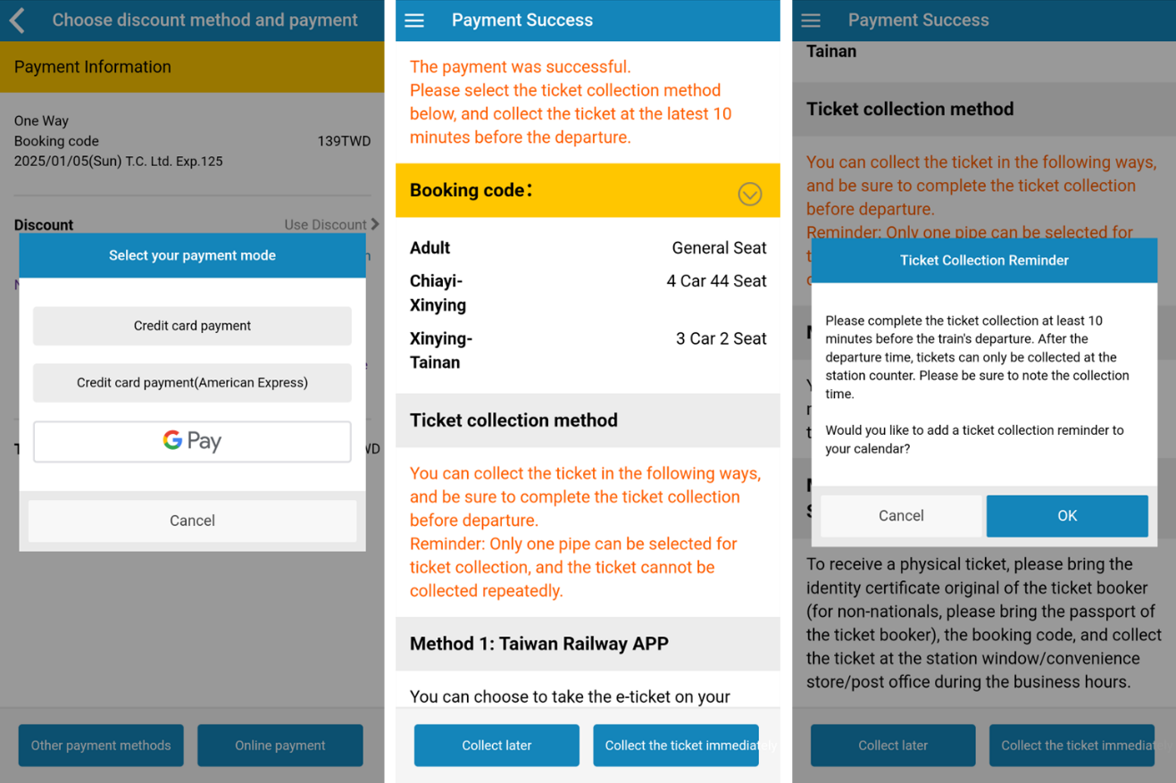

* + 1. Choose from **Credit card payment**, **Credit card payment (American Express)**, or your digital wallet (Apple Pay, Google Pay, or Samsung Pay).
    2. You will be directed to a payment screen where you will enter your digital payment information.

Once accepted, the **Payment Success** screen will appear.

* + 1. Tap **Collect the ticket immediately** to be directed to the ticket collection flow and receive your electronic or physical ticket, or tap **Collect later** to collect your ticket later, at least 10 minutes before the train’s scheduled departure. You may collect your ticket in person at the station for free, or at a convenience store/post office for an additional fee.
    2. If you select **Collect later**,the **Ticket Collection Reminder** pop-up will appear. Tap **OK** to receive a calendar notification when it is time to collect your ticket or tap **Cancel** if you do not need a reminder.
  1. To pay for your ticket in person, tap **Other payment methods**.

The **Convenience Store Payment** screen will appear.

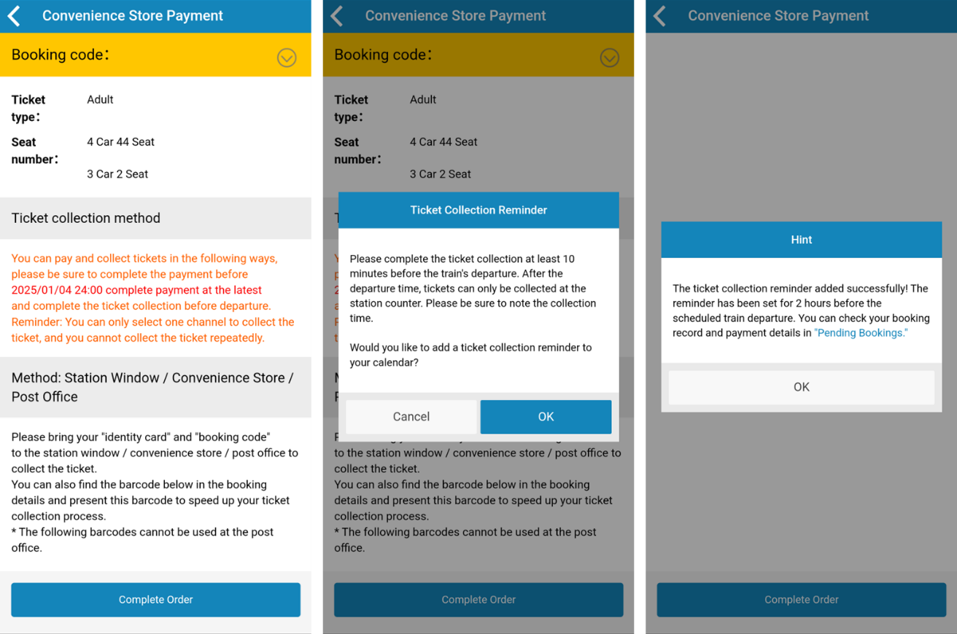

1. To pay and collect your ticket in person, bring your ID and booking code to the train station window, a convenience store, or a post office. Tap **Complete Order**.
2. The **Ticket Collection Reminder** pop-up will appear. Tap **OK** to receive a calendar notification when it is time to collect your ticket or tap **Cancel** if you do not need a reminder.
3. Once you pay for your ticket and collect it, you can access it through the **Tickets** button on the home screen, or through **My Tickets** on the navigation pane.

## Collect Paid Tickets on the Taiwan Railway E-Booking App

Railway tickets can only be used once collected.

To collect a ticket you have paid for:

1. Tap **Uncollect** on the Taiwan Railway E-Booking home screen, or tap **Pending Bookings** on the navigation pane, then **Uncollect ticket**.
2. Select the ticket you wish to collect. The **Booking Record Details** screen will appear, and the status of the ticket will be displayed as **Paid but not pick up**. 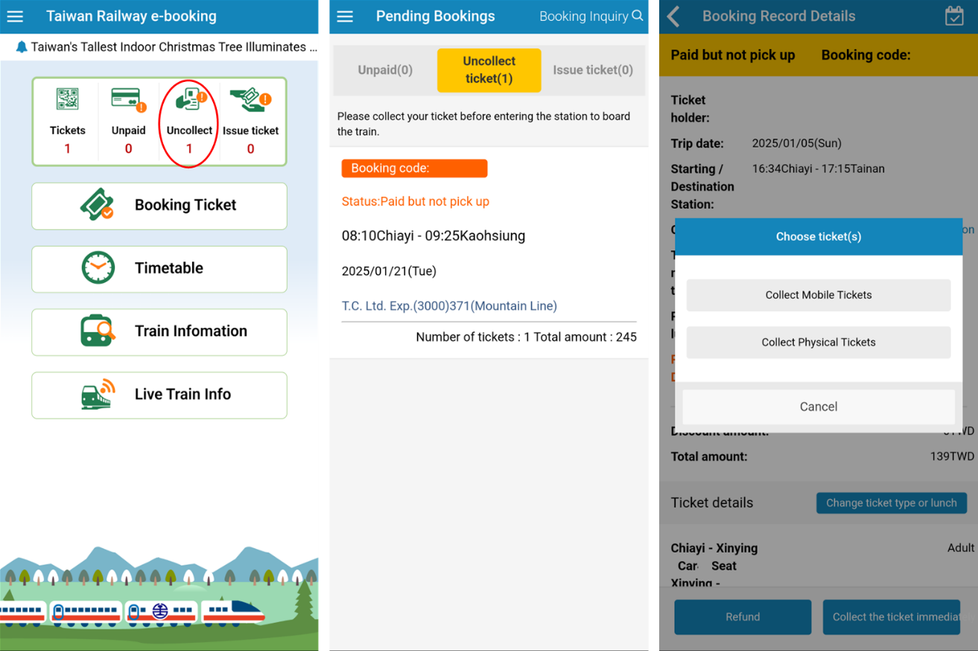
3. Tap **Collect the ticket immediately**. The **Choose ticket(s)** pop-up will appear. There are two options for collection: physical tickets or mobile tickets.
   1. If you want to collect a physical ticket at a convenience store, post office, or train station, tap **Collect Physical Tickets**.

The **Collect Physical Tickets** screen will appear.

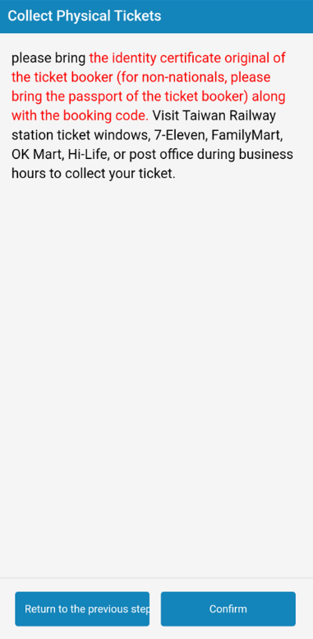

* + 1. Follow the instructions to bring your ID and booking code to the ticket collection location.
    2. Tap **Confirm**.
  1. If you want to receive tickets in the app, tap **Collect Mobile Tickets**.

The **Local Ticket Collection** screen will appear.

* + 1. Select the ticket you would like to collect. If you have purchased tickets for multiple riders, you can only collect one ticket on your device.
    2. Tap **Collect tickets and issue tickets**. The **Multi-Person Ticket** screen will appear. Your ticket information will be displayed on this screen.

*Note:* Tickets purchased for other riders will also appear on this screen with a ticket verification code. Other riders can use the ticket verification code and booking code to collect a ticket on their devices in the **Download Tickets** section of the app.

* + 1. Tap **Go to My Ticket** to be directed to your electronic train ticket.

Paid and collected electronic tickets can be accessed through the **Tickets** button on the home screen, or through **My Tickets** on the navigation pane.

Use Your Tickets on the Taiwan Railway E-Booking App

Follow this procedure to